Hurricane Delta – Its Wind and Rain Impacts on Louisiana
A Preliminary Report – October 12, 2020

By: Don Wheeler, Meteorologist

Only 44 days a devastating strike from category 4 Hurricane Laura, Hurricane Delta makes landfall near Creole, Louisiana - approximately 15 miles east from where Hurricane Laura came ashore near Cameron on August 27. Delta was the fourth named tropical system to make landfall in Louisiana this season joining Tropical Storm Cristobal, Tropical Storm Marco, and Hurricane Laura. The previous record was set in 2002 when Tropical Storms Bertha, Hanna, and Isidore joined with Hurricane Lili to strike the state. Delta, like its predecessor Laura, caused widespread power outages across the state and dumped heavy rainfall in excess of 10 inches.

Delta began as an area of disturbed weather in the eastern Caribbean the weekend of October 2. Models were indicating tropical formation of this system within a few days as it moved into the central Caribbean. Ahead of the system Tropical Depression 25, soon to become Gamma, was located over the northwestern Caribbean.
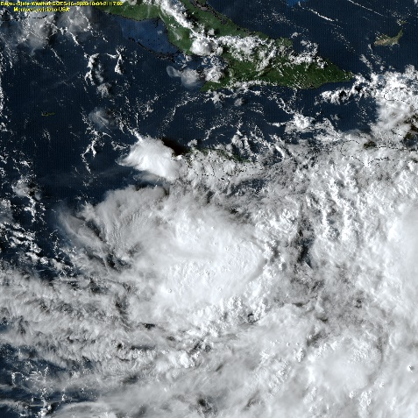
The National Hurricane Center issued the first advisory on “Potential Tropical Cyclone 26” at 5PM EDT, Sunday October 4 when the storm was just off the southeast coast of Jamaica. The first forecast track took the storm to the northwest over the western tip of Cuba, then into the southeastern Gulf of Mexico where it was to strengthen to hurricane force. Delta was to move to south of the Louisiana coast, then take a northward turn toward southeast Louisiana in response to an approaching trough. With time, this track would shift west and southwest ever so slightly with the eventual landfall occurring in southwest Louisiana.
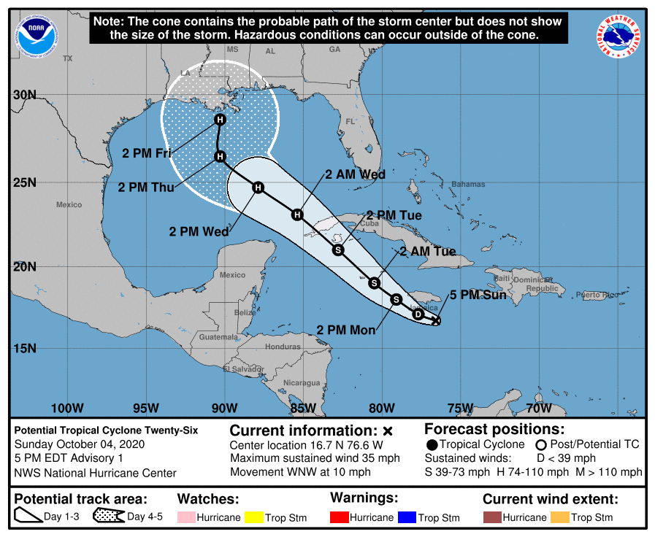
First Forecast Track 10/4/2020

Model guidance was rather accurate in predicting the general path of the storm but was initially conservative in the strength of the storm. Delta was initially forecast to approach the western tip of Cuba as a strong tropical storm or minimal hurricane before emerging over the gulf and then becoming a hurricane throughout the remainder of its life. The storm instead took a slightly west and southward jog taking aim on the northeastern tip of the Yucatan.

Unexpected rapid intensification occurred Monday night and Tuesday morning as the storm entered the northwestern Caribbean – an area notorious for rapidly intensifying tropical systems. The rapid intensification of the system, however, was not anticipated until Monday afternoon October 5. Delta commenced to set an Atlantic Basin record for fastest intensification of a tropical system from a tropical depression to a category 4 hurricane. As of the 5AM EDT advisory on Monday, October 5, the winds were 35 mph (tropical depression) with a pressure of 1006mb/29.71” of mercury while located 90 miles south of Negril, Jamaica. By 11AM EDT Tuesday, October 6, Delta was a category 4 hurricane with sustained winds of 130 mph and a pressure of 954mb/28.17” – a drop of 52mb in only 30 hours! With pressure changes, the corresponding wind adjustments come several hours later. While the pressure bottomed out at 954mb it did rise to 956 mb on the 2PM EDT advisory. The winds, however, steadily increased to 145 mph as of the 5PM EDT advisory Tuesday.

Fortunately for residents of the Yucatan, the storm did weaken considerably prior to coming ashore. Delta made landfall along the northeast coast of the Yucatan Peninsula near Puerto Morelos, Mexico around 5:30 AM CDT (1030UTC) with maximum winds of 110 mph (category 2). Delta moved across the extreme northeastern tip of the Yucatan and re-emerged over the warm waters of the southern Gulf of Mexico Tuesday afternoon. Winds decreased to 85 mph while over land but the storm was forecast to re-strengthen over the warm waters of the central and western gulf and to once again become a major hurricane.

Model guidance was rather consistent in bringing the storm inland somewhere along with Louisiana coast. Initially the southeast Louisiana coast was targeted but the track shifted west with time. Unfortunately, it was becoming increasingly apparent that Delta could strike eerily close to Laura’s landfall and affect already storm-weary portions of the state. If there was to be a silver lining to the storm, Delta was forecast to begin a weakening trend just prior to striking the coast due to forecast southwesterly windshear and colder sea-surface temperatures near the coast.

Delta did re-intensify to major hurricane status with 115 mph winds as of the 4PM CDT advisory Thursday, October 8 while 345 miles south of Cameron, Louisiana. Satellite imagery was showing an ominous and growing storm that took up the western half of the Gulf of Mexico. The imagery was also showing evidence of wind shear over the Texas coast and across Louisiana which was good news in that it would serve to weaken the system prior to landfall.
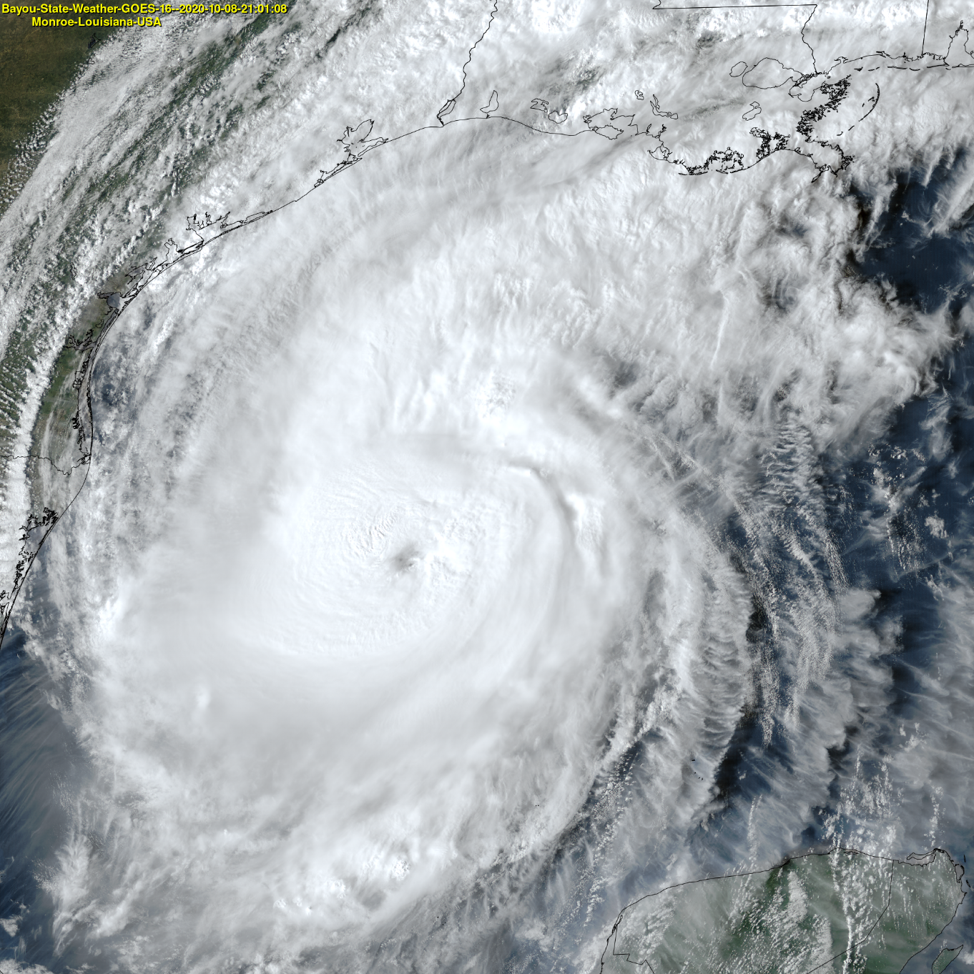
Major Hurricane Delta with 115 MPH Winds (Source: Bayou State Weather)

Delta maintained major hurricane status through the 1PM CDT special advisory with winds of 115 mph, although briefly peaking at 120 mph for a few hours Thursday night/Friday Morning. As forecast, Delta began to encounter conditions not conducive for further strengthening and was, in fact, forecast to weaken slightly before making landfall.

Increased wind shear from the southwest, cooler sea-surface temperatures, and dry air intrusion did indeed begin to affect Delta as it approached the coast. Satellite imagery and reconnaissance indicated signs of disorganization by late morning Friday.

Delta weakened to category 2 status as of the 1PM CDT advisory with sustained winds of 110 mph. The vertical structure of the storm was being disrupted due to the increased wind shear from the southwest. The once partially visible eye disappeared. Radar imagery showed an asymmetrical storm with the bulk of the precipitation found in the northern hemisphere due to dry air intrusion. Visible and infrared satellite imagery depicted a warming of the clouds in the southern hemisphere at 21:00Z

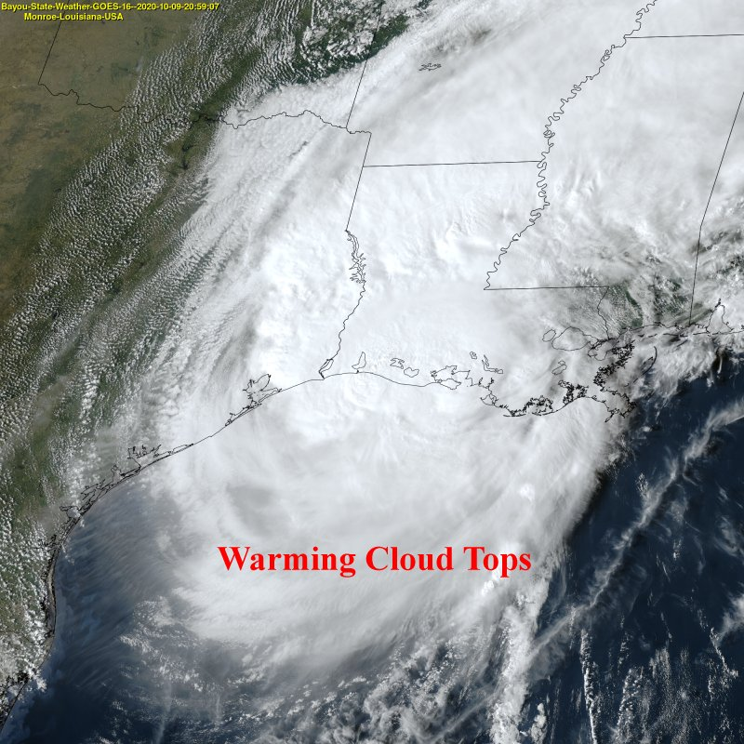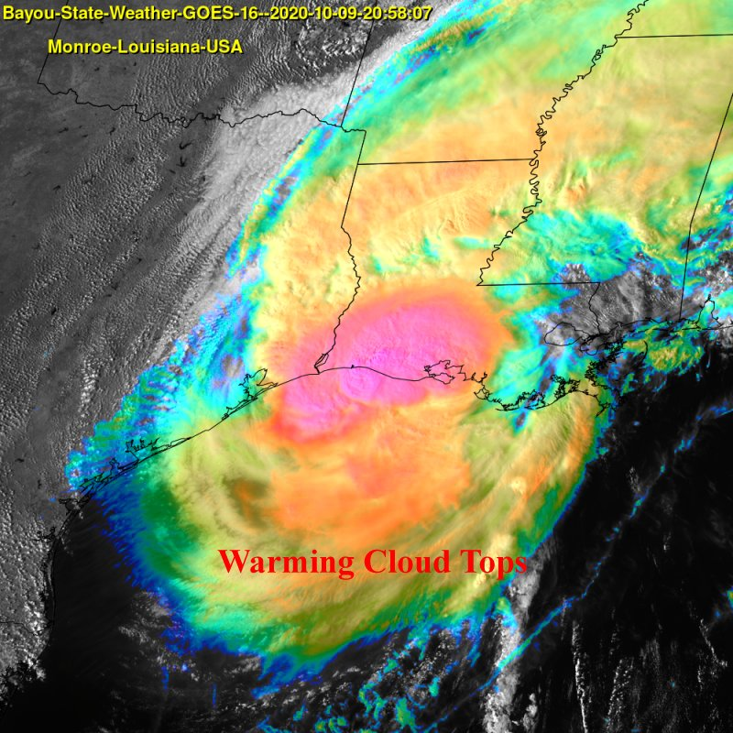
Visible/IR Satellite Imagery Depicting Warming Clouds in the Southern Semicircle (Source: Bayou State Weather)

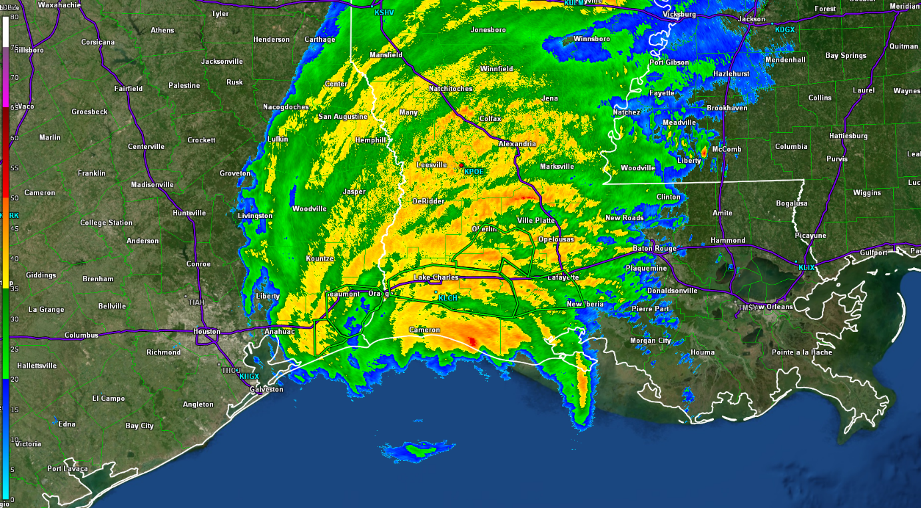
Radar Image at 2100Z Showing Lack of Rainfall in the Southern Semicircle (Source: Bayou State Weather)

Hurricane Delta made landfall near Creole, Louisiana at 6:00 PM CDT (2300Z). The landfall was less than 15 miles from where Hurricane Laura came ashore near Cameron just 44 days earlier. Sustained winds at the time of landfall had decreased to 100 mph. The highest recorded gust for the event was 100 mph which occurred in extreme southeast Texas at Texas Point near the Louisiana border.

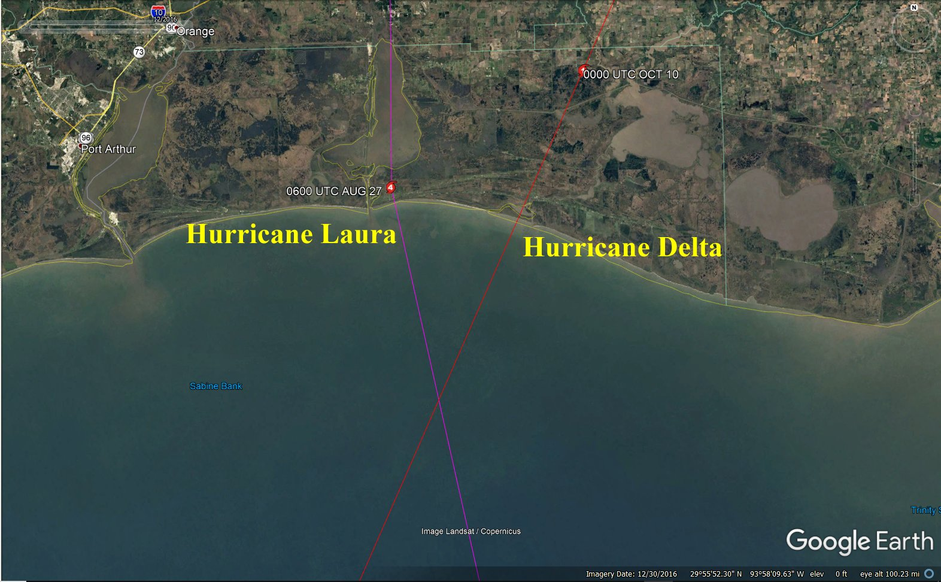
Hurricane Laura Landfall (left) and Hurricane Delta Landfall (right)

Upon landfall, Delta began to weaken at it began its northeastward trek across Louisiana from southwest to northeast. A trend that began prior to landfall, an expansion of the wind field, continued. Delta produced winds in excess of tropical storm force across much of the state, perhaps 85%. These winds were also experienced in adjacent east Texas, much of south and western Mississippi, and southeast Arkansas. Gusts exceeding 60 mph were recorded as far north as northeast Louisiana where the Monroe Regional Airport recorded a 63mph gust at 1:30 AM Saturday morning, October 10.

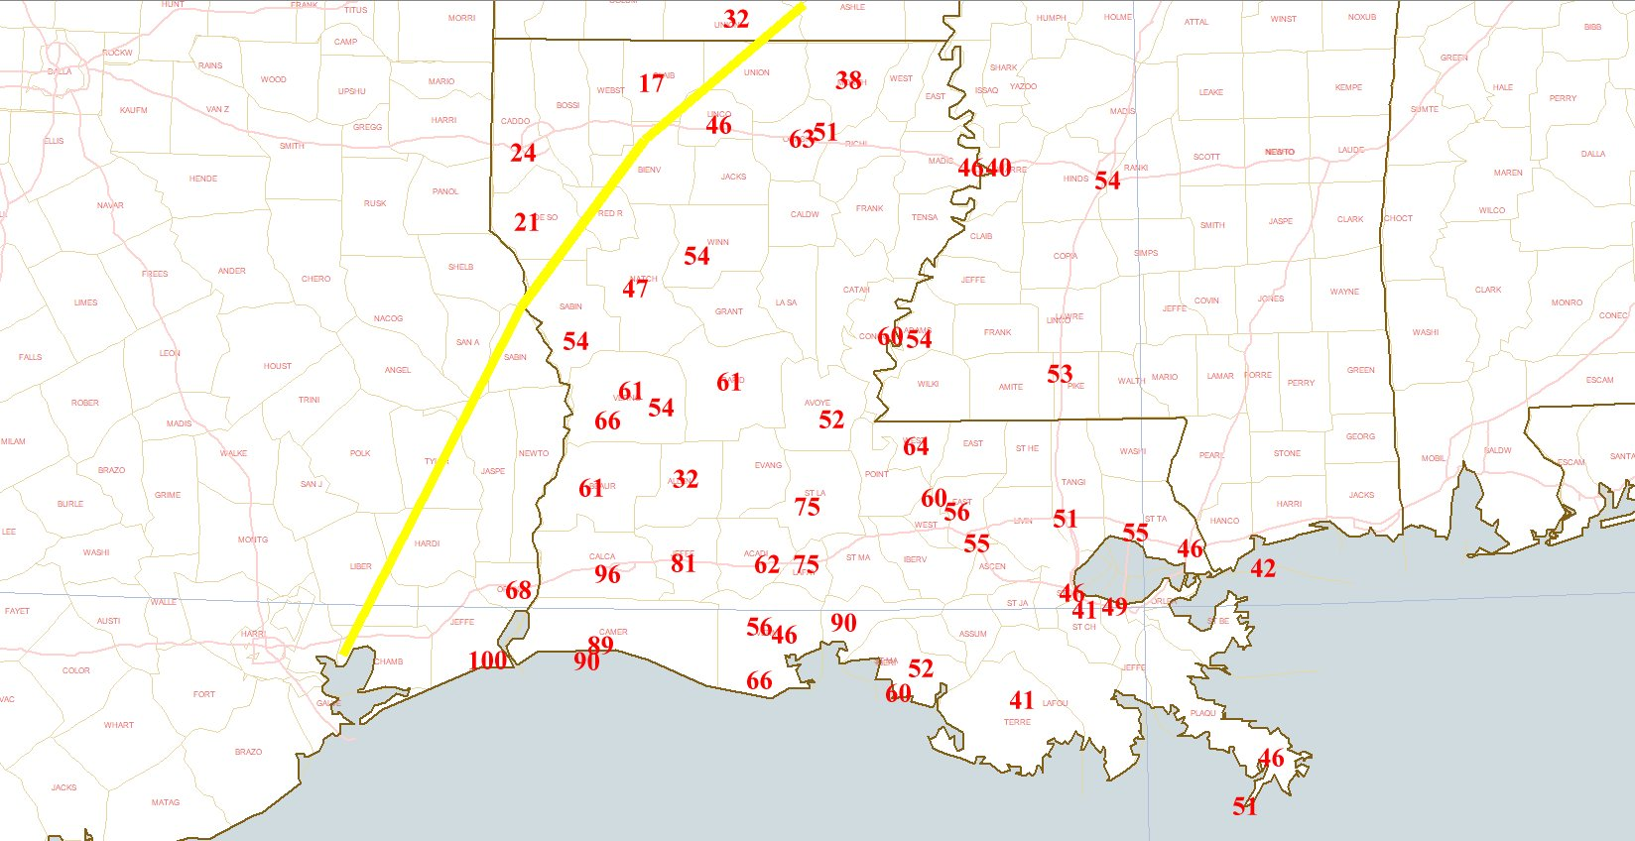
Recorded Wind Gusts – Yellow Line Depicts Extent of Tropical Storm Force Winds (39 mph or higher)
(Source: Bayou State Weather)

Widespread power outages occurred across the state due to the extensive wind field exceeding 600,000 outages. In a statement by Louisiana Governor John Bel Edwards, “The peak was 638,000 outages across the state of Louisiana. As of noon [Saturday] that number had decreased to 600,000. So, restoration appears to be happening more rapidly than was the case after Laura, and that’s because the damage to the infrastructure is not as significant. But that’s still an awful lot of power outages,” he added. This figure accounts for nearly 25% of all power customers in the entire state. (Source: WAFB TV)

Entergy, which does not provide all power needs to the state, reported 495,000 power outages within all of Entergy’s service territories (east Texas, Louisiana, Arkansas, and Mississippi). (Source: Entergy).

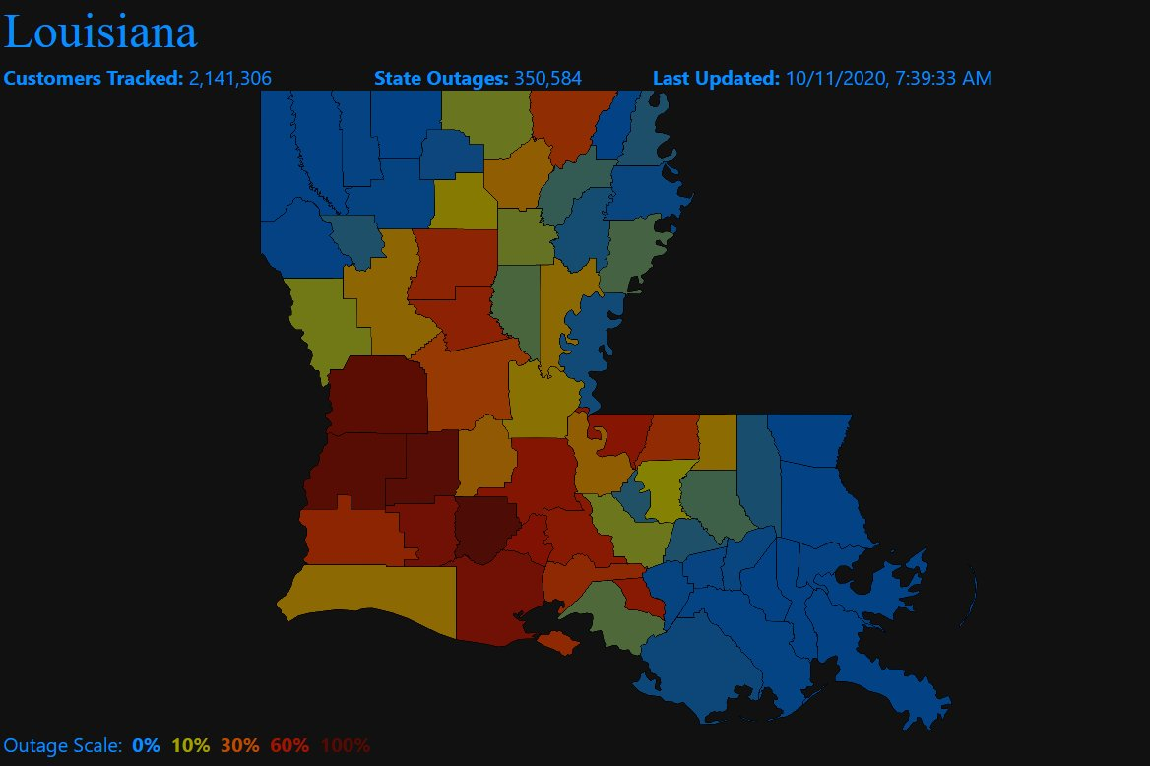
Louisiana Power Outage Map as of 10/11/2020 (Source: PowerOutage.US)

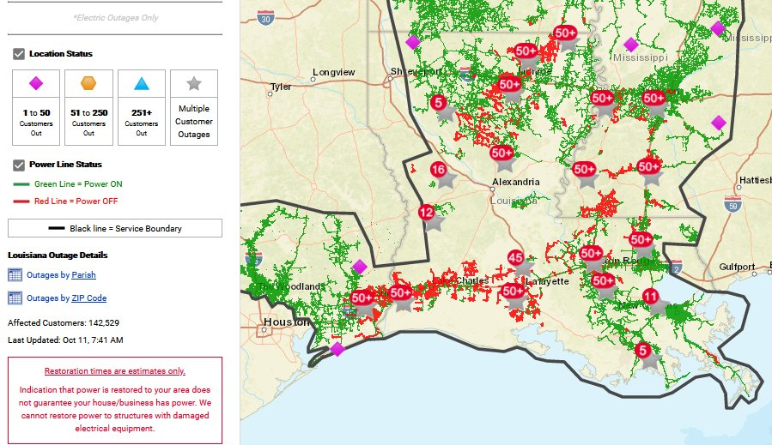
Entergy Power Outage Map as of 10/11/2020 (Source: Entergy)

Rainfall totals were extensive across the state. Measured readings from the Community Collaborative Rainfall, Hail, and Snow Network (CoCoRaHS) recorded four-day totals exceeding 10 inches across portions of central, northeast, and southeast Louisiana most of which fell from Friday, October 9 through Saturday morning, October 10. Alexandria reported the highest value of 13.07”. Another cluster of higher totals exceeding 10 inches was noted northeast of the Baton Rouge area where the highest value of 10.54” was recorded at station Brownfields 5.8 NE.

Automated gauges across southwest Louisiana recorded values in excess of 15 inches. A recording station in Calcasieu Parish, EB L-14 @ Packing House Road, recorded 17.57” for the highest amount. The heavy rainfall amounts did produce flash flooding along and on either side of the center of the storm’s path. The dry air that did intrude the storm assisted in keeping the totals from being even higher.

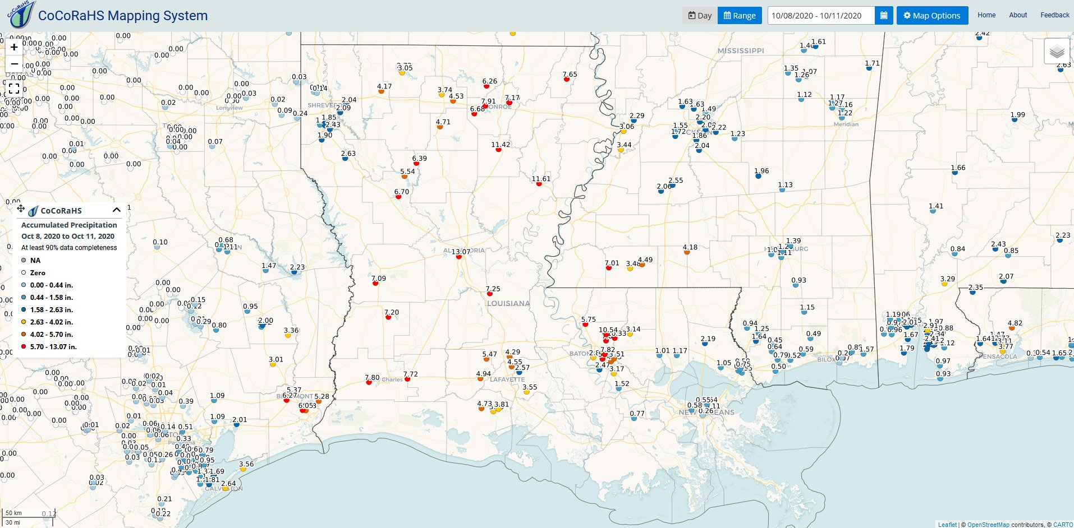
4-Day Rainfall Totals from the CoCoRaHS Network from October 8-11

Delta’s final track took it through the heart of Louisiana maintaining hurricane strength just south of Alexandria. It was downgraded to a tropical storm with 60 mph winds as of the 1AM CDT advisory 15 miles east-southeast of Alexandria. Delta continued northeastward as a tropical storm while over extreme northeast Louisiana 45 miles east of Monroe, then was downgraded to a tropical depression 65 miles north-northwest of Jackson, Mississippi at 10AM CDT.

Supporting Images

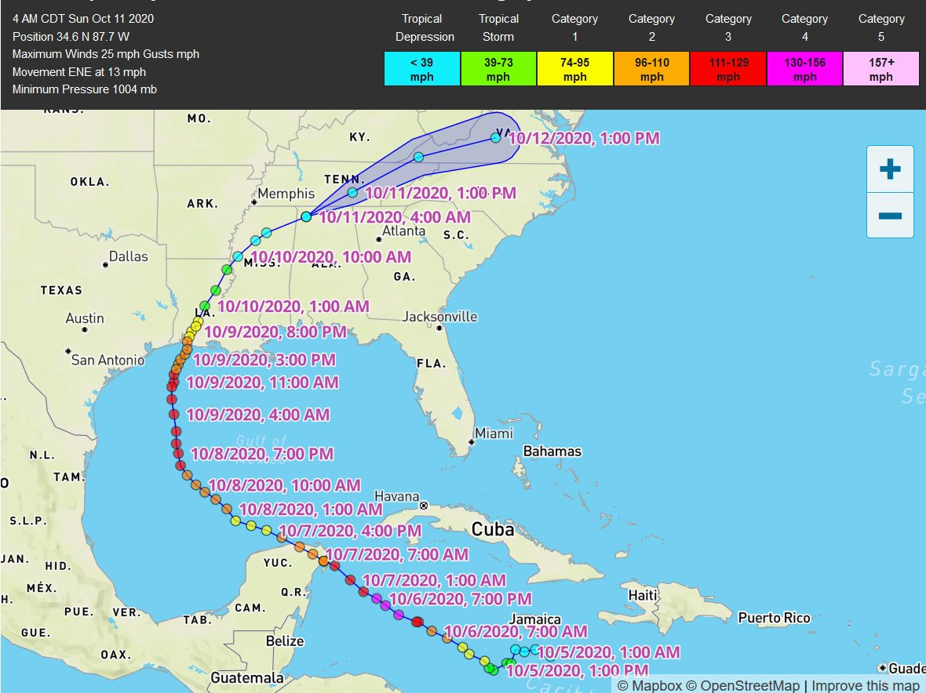

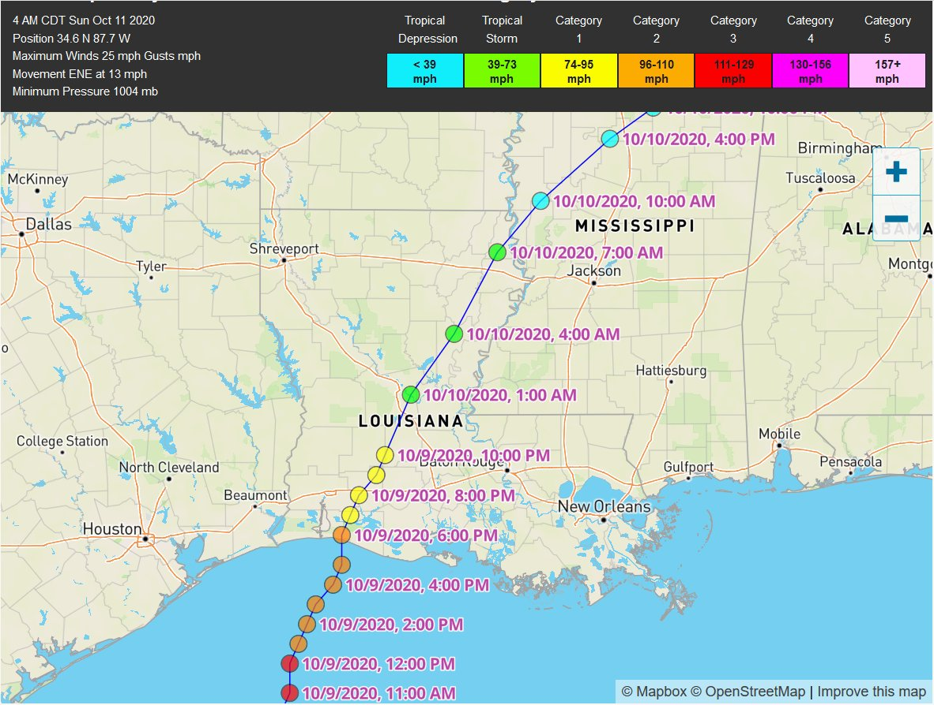

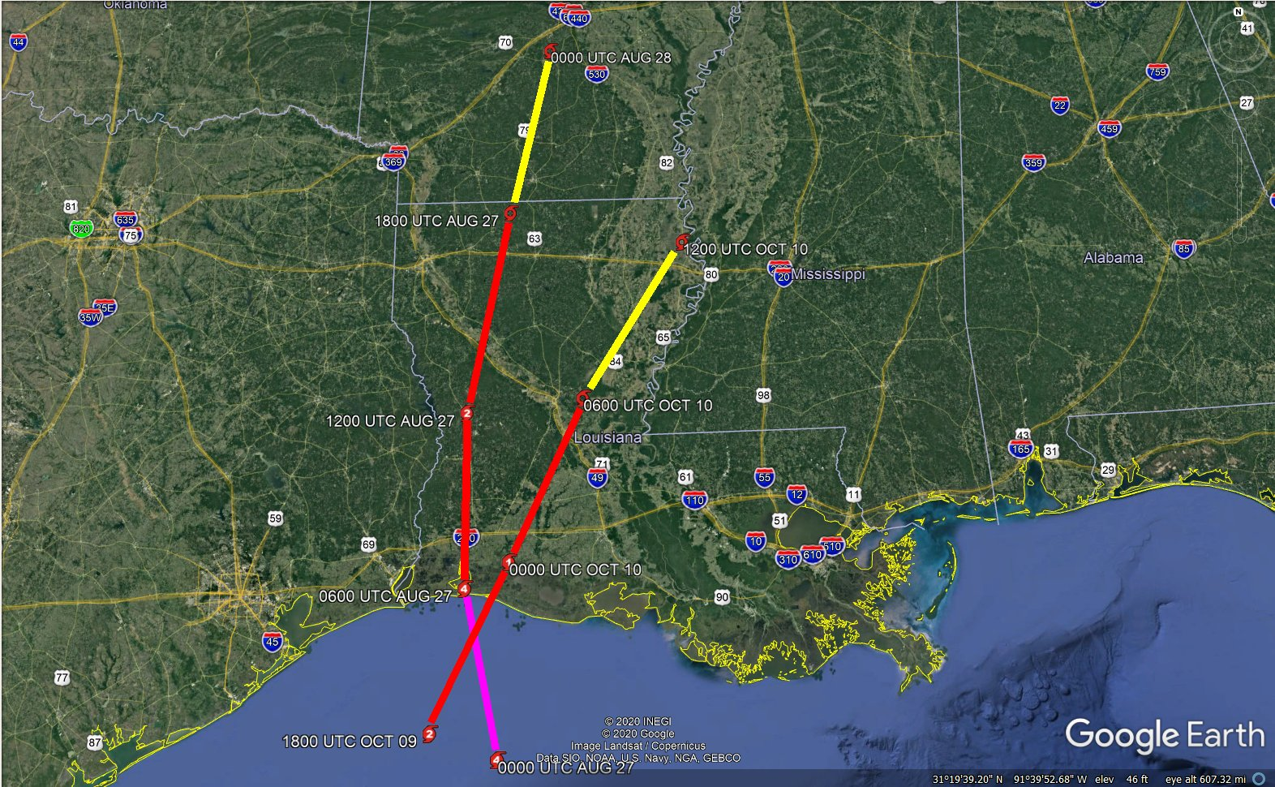
Hurricane Laura and Hurricane Delta Paths through Louisiana

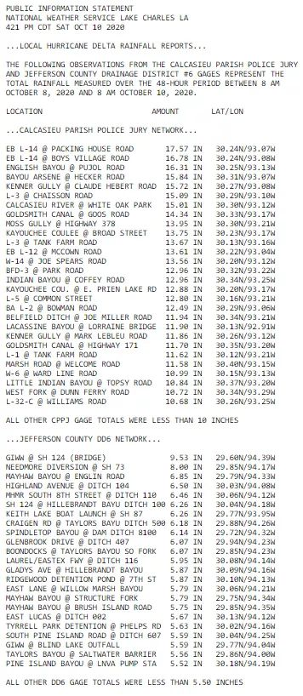

Automated Gage Rainfall Totals Calcasieu Parish and Jefferson County, Texas

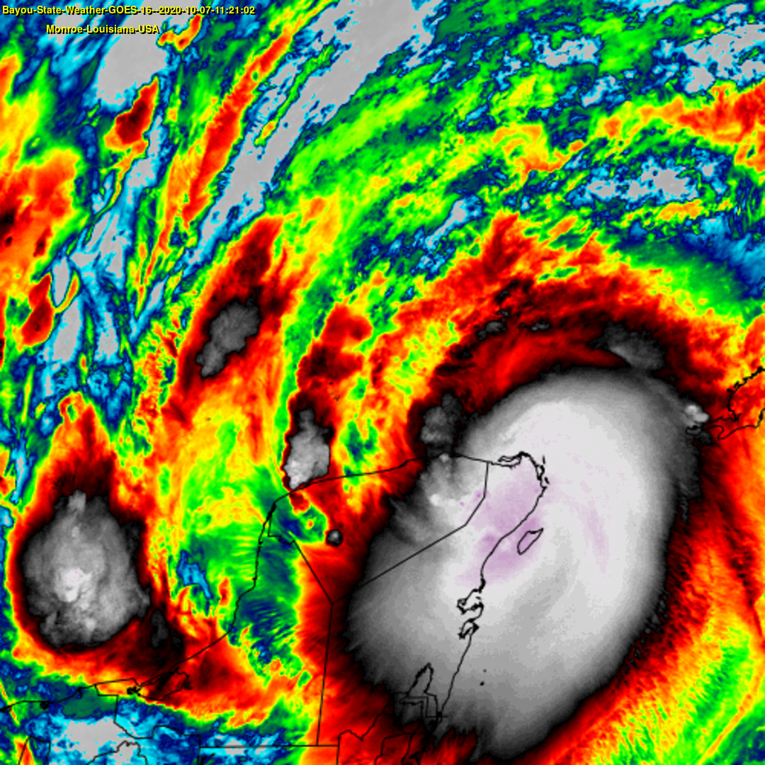
Hurricane Delta Yucatan Peninsula Landfall

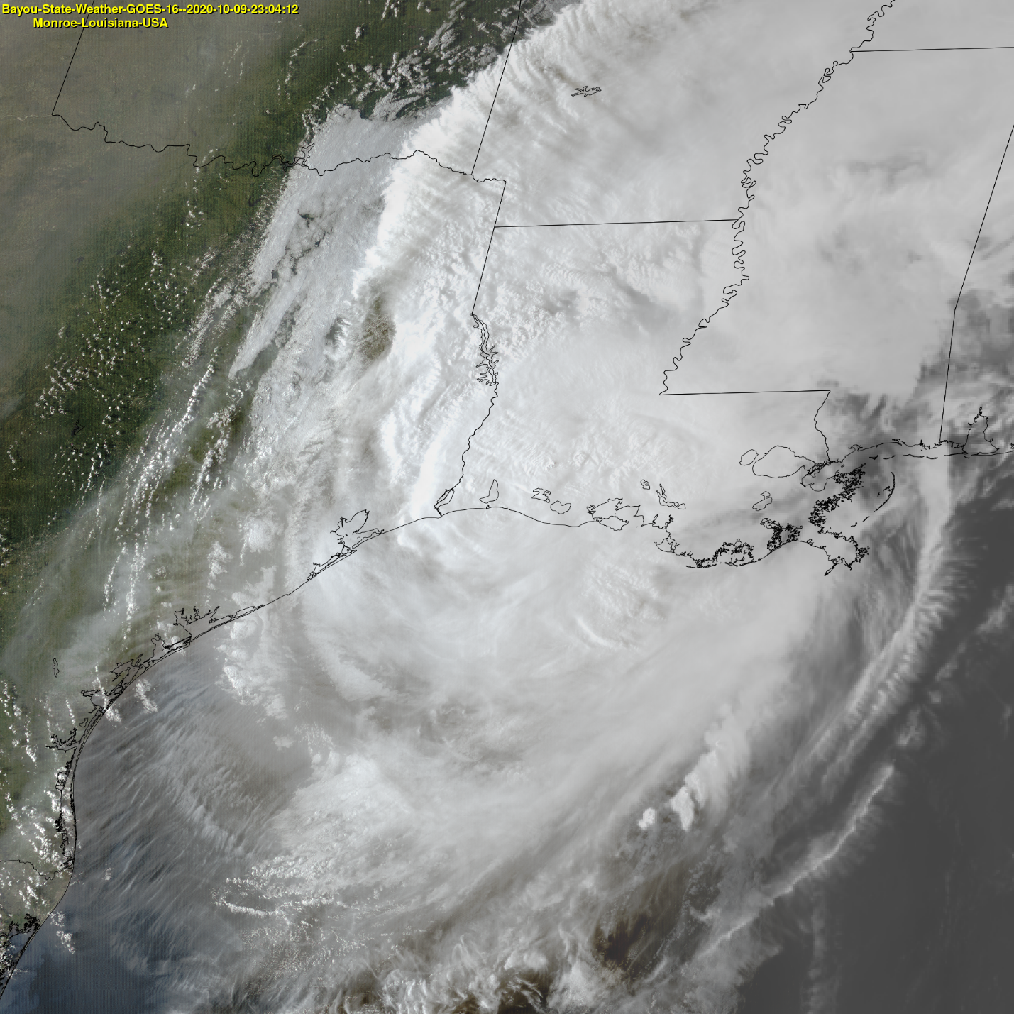
Hurricane Delta Louisiana Landfall (Visible Image)

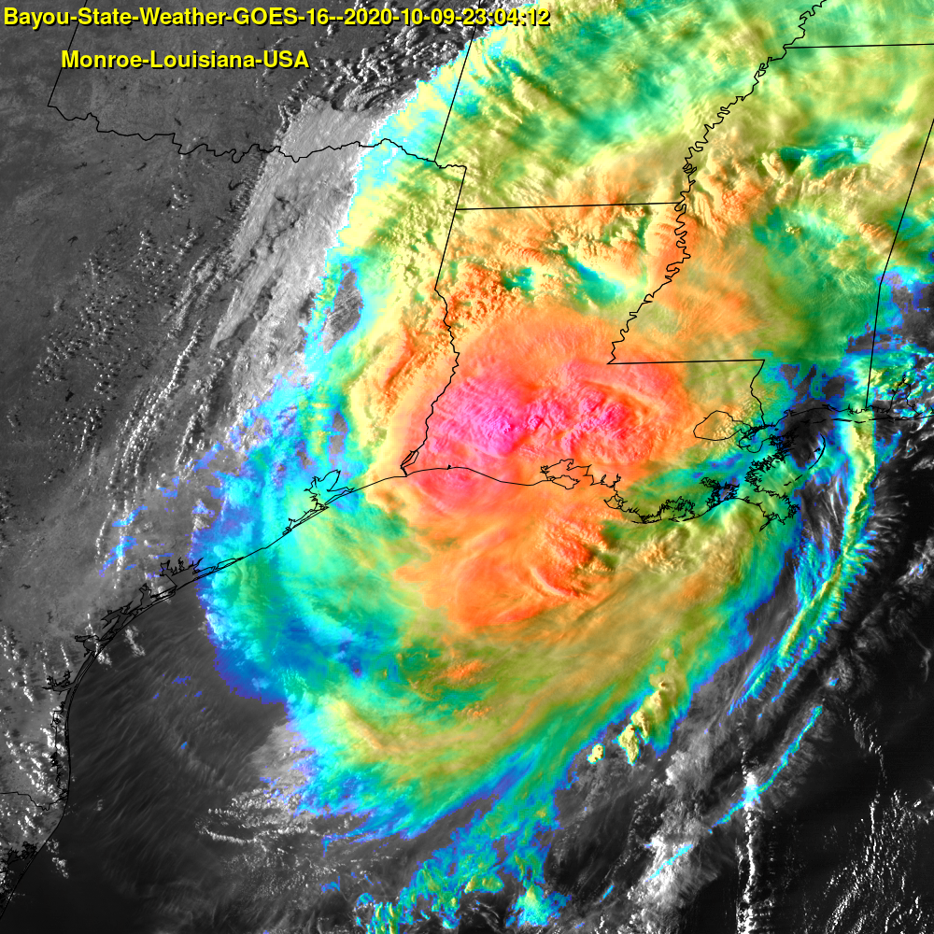
Hurricane Delta Landfall (IR Enhanced Image)

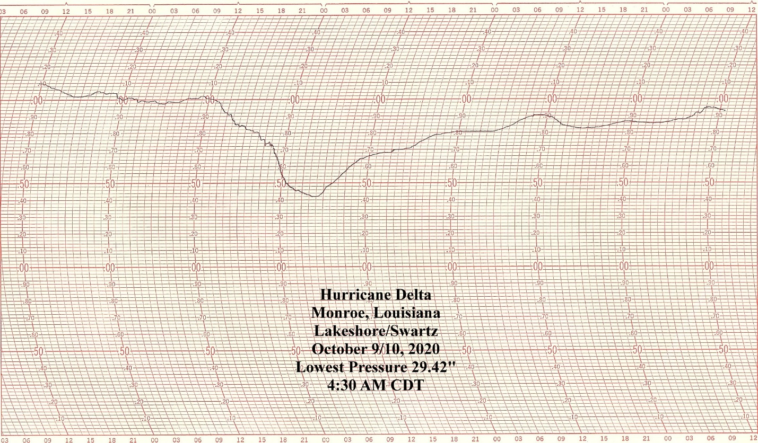
Barograph Tracing from Monroe/Lakeshore/Swartz, Louisiana

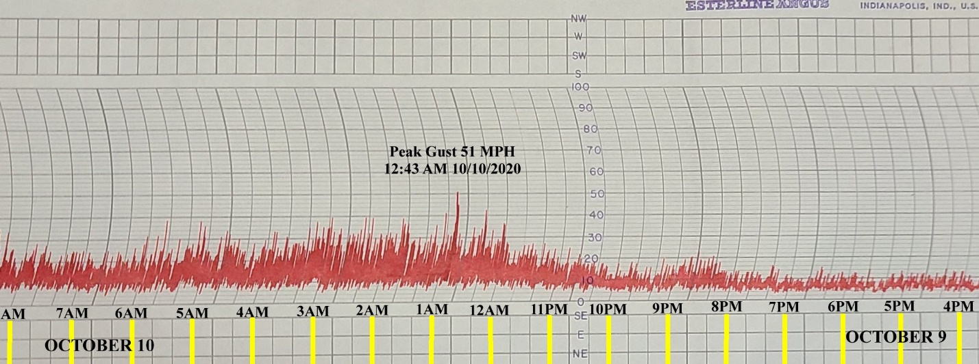
Delta Wind Trace from Lakeshore/Swartz (Ouachita Parish)

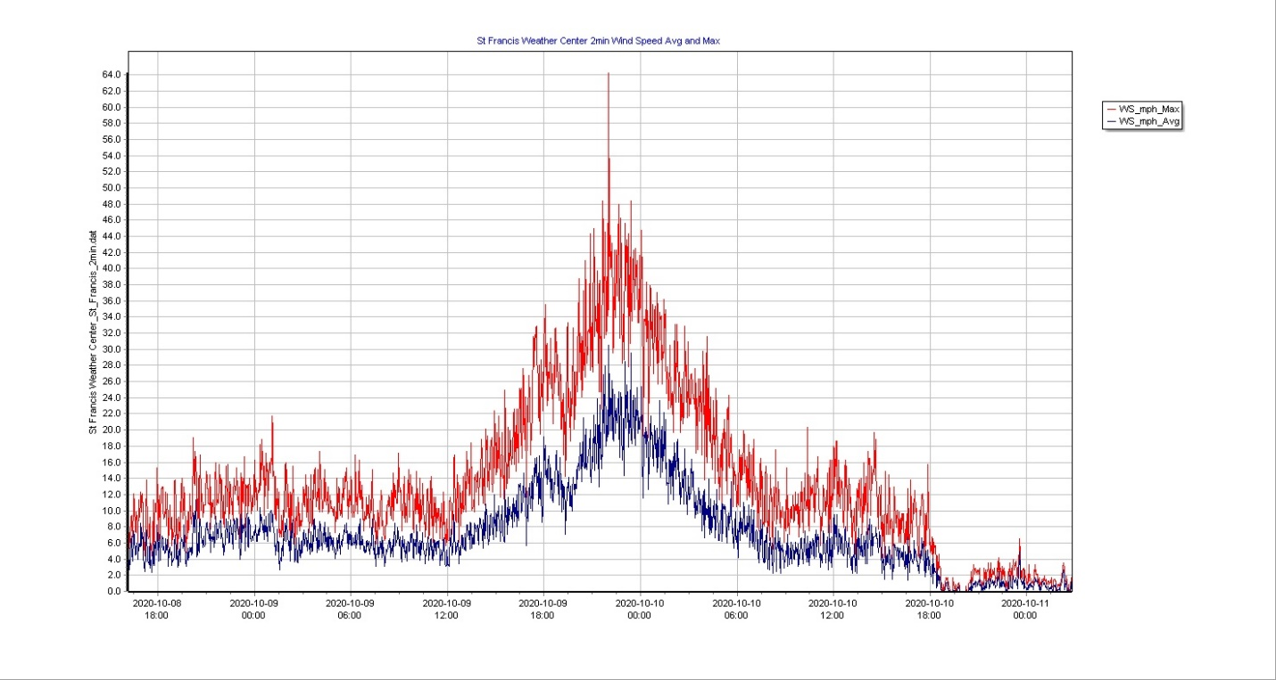
Delta Wind Trace from St. Francisville, LA (St. Francis Weather)

Sources

Bayou State Weather, LLC
Community Collaborative Rainfall, Hail, and Snow (CoCoRaHS) Network
Entergy
National Weather Service – Lake Charles
National Weather Service – Shreveport
National Weather Service – Jackson
National Weather Service – New Orleans
National Hurricane Center
PowerOutage.US
St. Francis Weather, LLC
WAFB-TV
Weather Underground

